Interview

# Interviewer – Mr Kgato Rankgomo

# Interviewee – Mr Kentsenao Baseki

## Time – 10:30am – 12:00pm

Q. What are the main services you’d expect customers to access?

a. Account creation, being able to deposit and withdraw and transfer of funds between accounts.

Q. Speaking of accounts, should the system allow multiple accounts per customer?

a. Yes i expect a checking and a savings account

Q. What about a customers transaction history? Do you want to be able to access it?

a. Yes. I expect to be able to access the transaction history. To be able to view my previous deposits and withdrawals.

Q. Would you like the system to be able to provide bill payment services? Like buying airtime, electricity and water?

a. Those aren’t very necessary now.

Q. what types of user authentication should the system support when you’re logging into your account?

a. Only a password should suffice.

That should be all. Thank you for your time.

# CLASS DIAGRAM

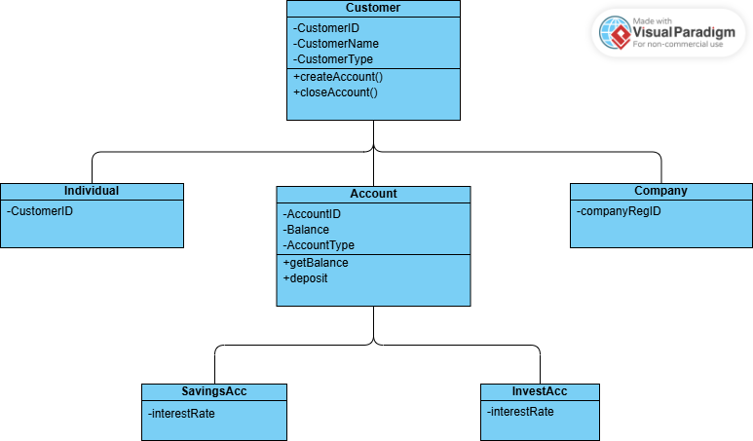

# STATE DIAGRAM

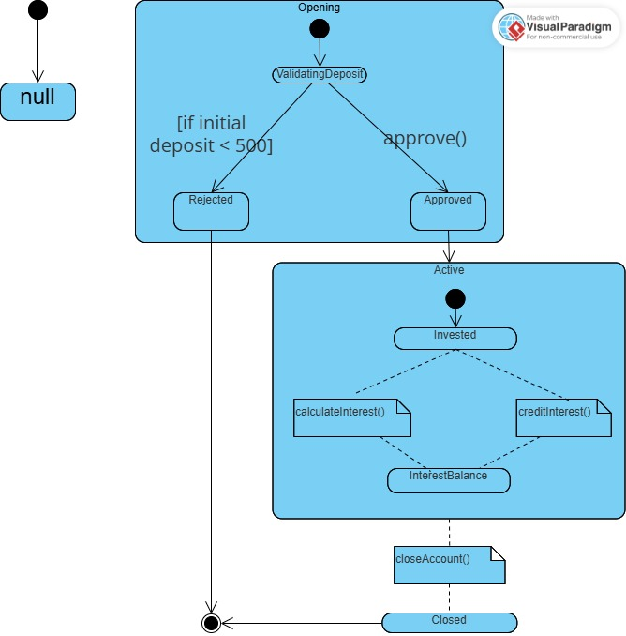

# USE CASE DIAGRAM

